LEADERSHIP EXCELLENCE COACHING

Life After the Paycheck

A Working Guide for Today's Session — Retirement Transition Workshop
YOUR READINESS SNAPSHOT
DOMAIN | WHAT IT'S REALLY ASKING | RATE 1 (NOT READY) – 10 (VERY READY)
Identity | Who am I without my title? | _____ / 10
Purpose | What will pull me out of bed? | _____ / 10
Time | Structured and unstructured days | _____ / 10
Relationships | Spouse/partner, friends, community | _____ / 10
Money Mindset | Not the plan — how you feel about spending it | _____ / 10
Health & Vitality | Energy for the life you're picturing | _____ / 10

FIVE YEARS IN
It's five years from now. Retirement has gone well. Two sentences: what does a normal Wednesday look like, and what's one thing you're proud you didn't put off?

THE RQ FRAMEWORK
IQ  What you know about the transition | EQ  How you manage the thoughts & feelings that come with it | SQ  The new identity, purpose & meaning you build | AQ  How resilient you are when plans change
IQ + EQ + SQ + AQ = RQ (Retirement Quotient)
Want your own RQ score? The RQ Profile assessment (retq.org) is a personal online assessment that scores you across retirement knowledge, work life, and personal life. It is included with a coaching package.

Beth Petrie, ICF Certified Coach  Leadership Excellence Coaching  leadershipexcellencecoaching@gmail.com · 443-842-4242 | 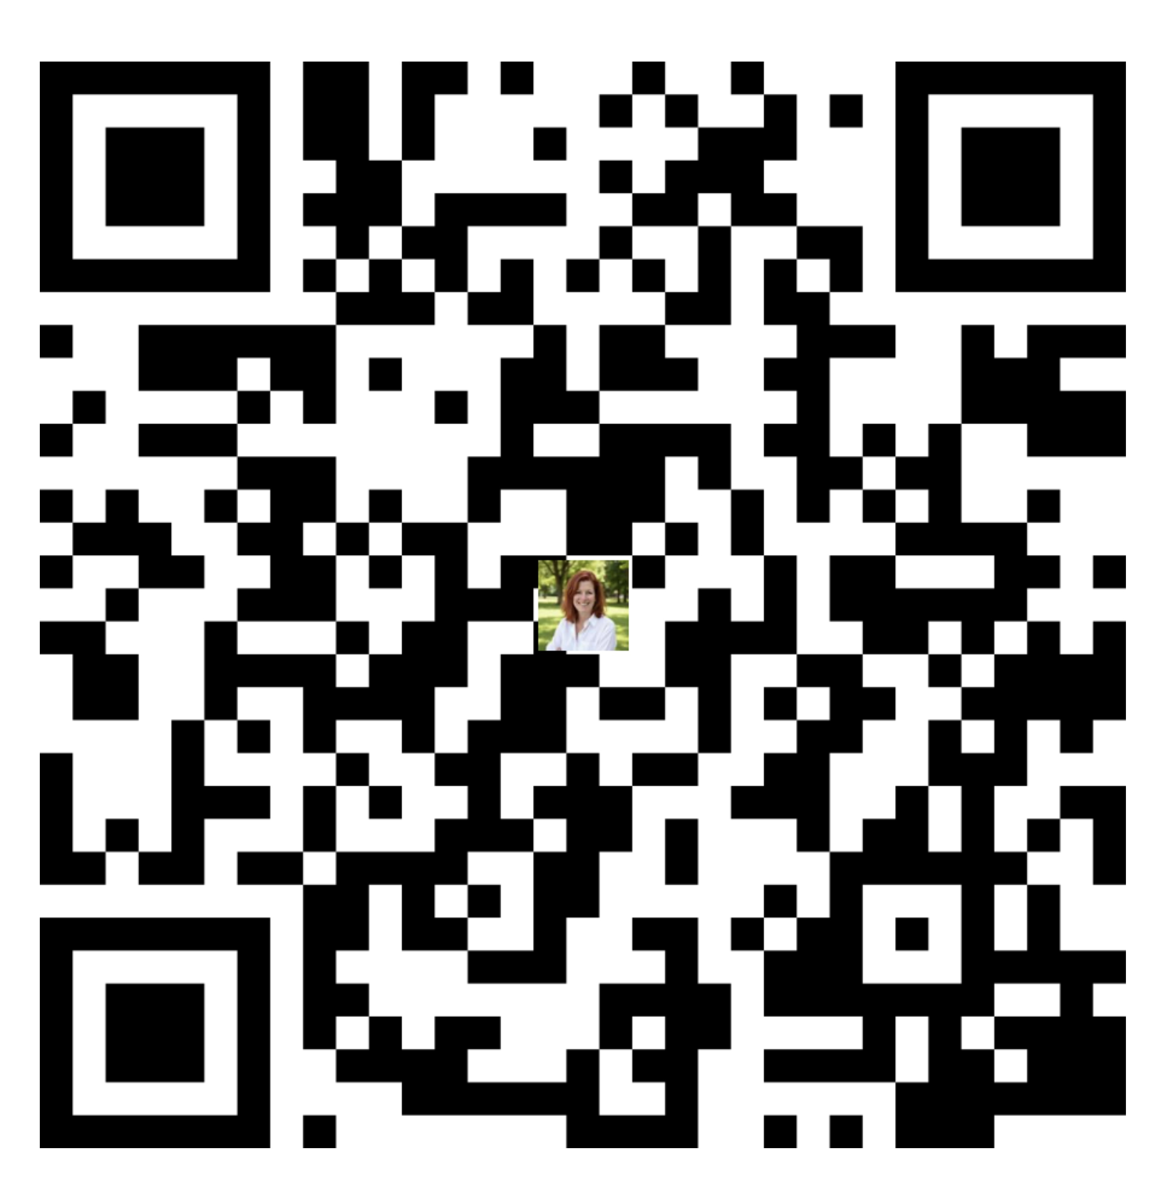  BOOK A CALL

